



Look and answer



Answer the questions:

1- In your opinion which is easier to grow?
2- Which one would you like to grow?

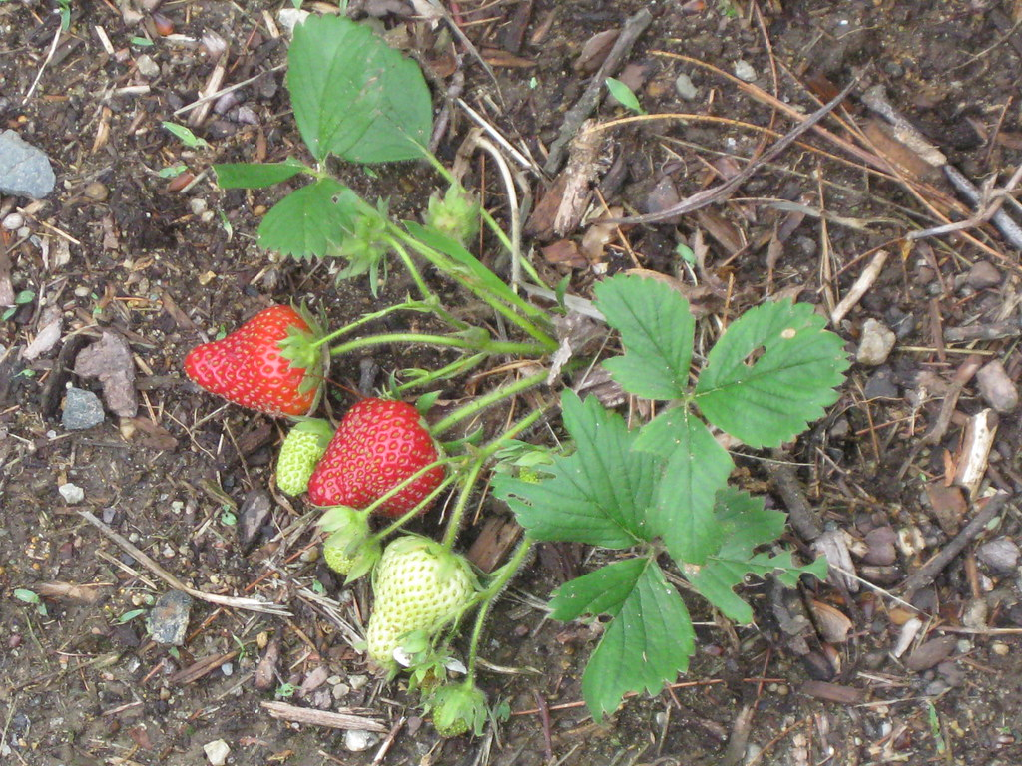
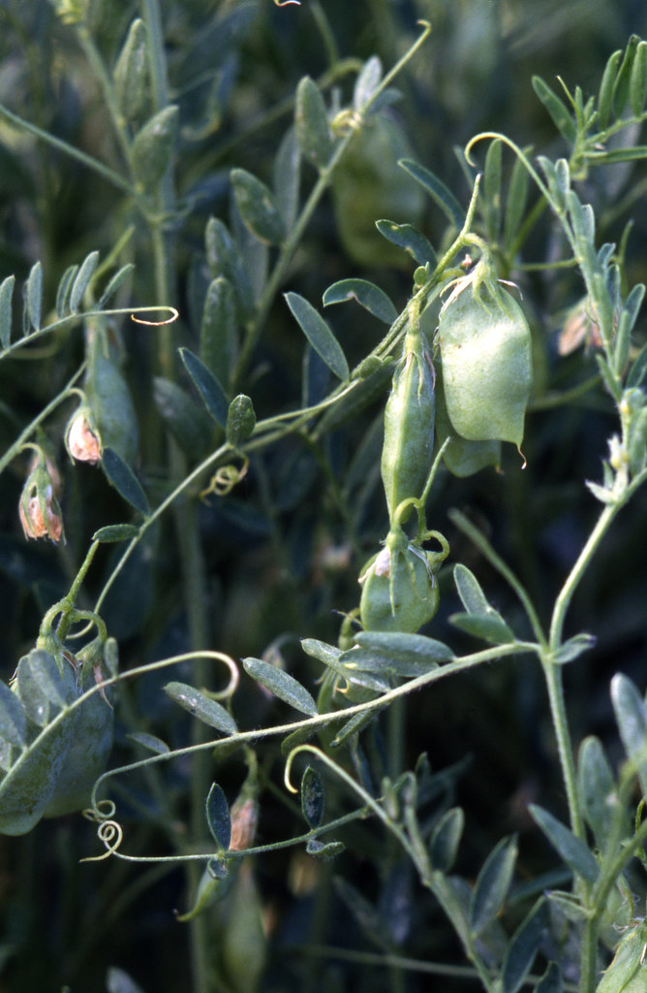
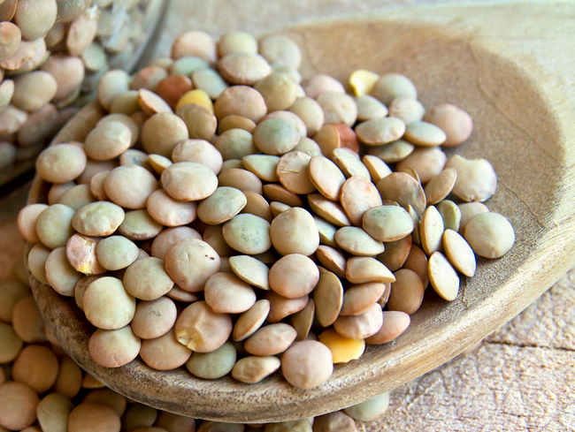
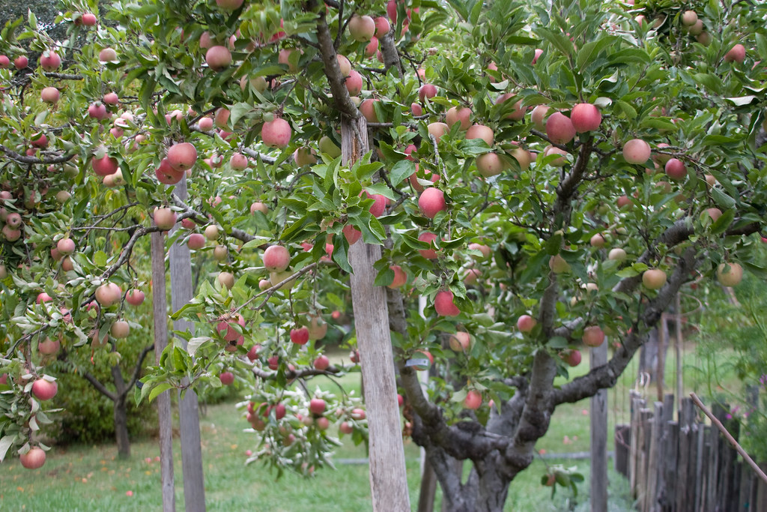
3- Which one do you prefer to eat?
4- Which one does your classmate prefer?

-Read the questions.
-Look at the pictures.
-Circle your answer.





