



Draw your conclusions




Answer the questions, then compare with your mates' results.
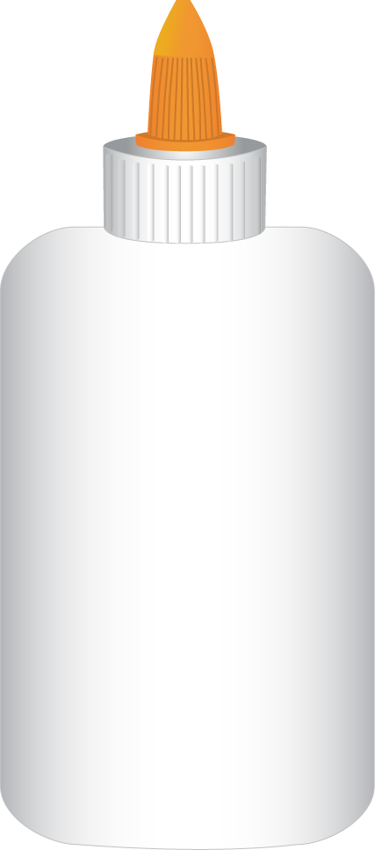
What did you get? Take a picture of it and paste it here.
1. What did you use?
a. soil and stones
b. Stones
c. Soil
2. How many times do you water the plant?
a. 2 times a week in autumn and winter or 4 times in spring and summer
b. every day
c. I put the plant where the rain can water it.
3. Does the sunlight get to your plant?
a. Yes, all the time
b. No, nothing
c. Yes, but not every moment.
4. Did you use fertilizer?
a. Yes, a natural one
b. No.
c. Yes, a chemical one.
5. Where did you plant the seed?
a. Near the surface
b. Far from the surface.
- In the middle of the pot.



