


Investigate the uses of water and electricity


- What are the common uses of water in your house?

- ………………………………………………………….
- ………………………………………………………….
- ………………………………………………………….
- ………………………………………………………….
- ………………………………………………………….
- ………………………………………………………….
- ………………………………………………………….

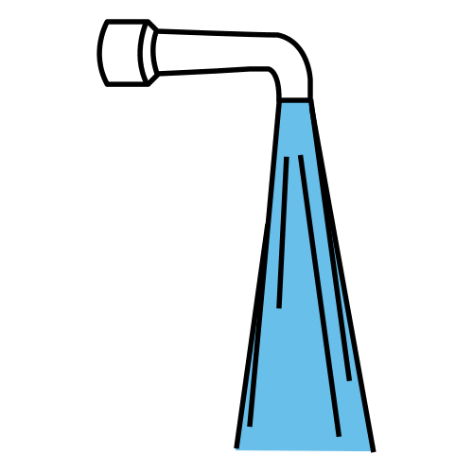

- And the common uses of electricity in your house?

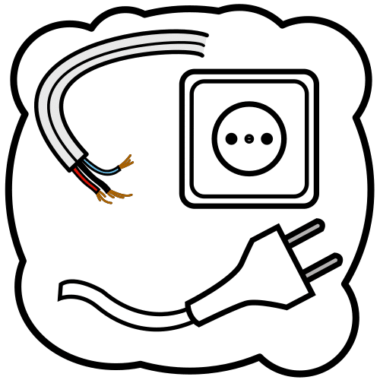
- ………………………………………………………….
- ………………………………………………………….
- ………………………………………………………….
- ………………………………………………………….
- ………………………………………………………….
- ………………………………………………………….
- ………………………………………………………….


Do you need help? Here you are some examples:
Some uses of water: flush the toilet, run the dishwasher, take a bath, laundry, wash your hands, brush your teeth, take a shower, wash dishes by hand, water the plants…
Some uses of electricity: lights, laptop, mobile phone/tablet, television, video game console, hairdryer, dishwasher, tumble dryer, air conditioning, oven…



