


Decalogue check-list


- Checklist


- Check the sentences in your Decalogue. Colour the light bulbs:
= poor = good = excellent
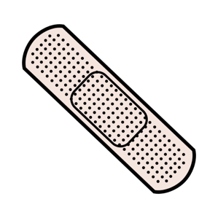
- Correct the items with 1 coloured light bulb.



Sentences are short and direct (no more than 20 words).
You use “should” to make suggestions.






You use “have to” for obligations.
You use the vocabulary used in the unit.

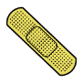
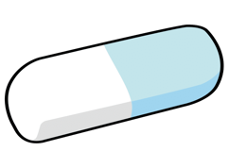

There are recommendations for a good use of energy.
There are recommendations to protect the climate.



You make good use of capital letters and punctuation.
The actions in the decalogue can be done in your daily life.



