



Battle chores



Can you think of any other family members? Write them down on the left.
Can you think of any other chores? Draw them at the top.
Use the table below to mark who does what in your family with an animal print.
My family’s chores
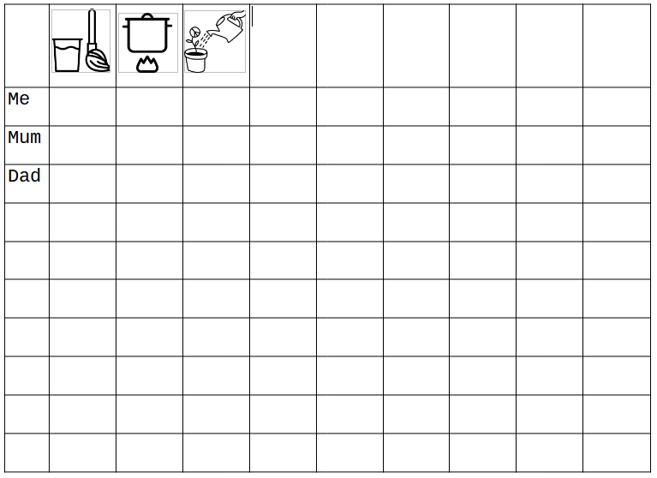
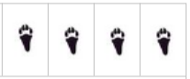
Rabbit

Bird 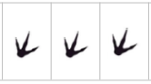
Dog 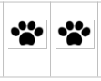

Try to imagine who in the family of your classmate does which chore.
Use the table below to mark his or her answers.
For example, you can ask: “Does your dad cook?” If he or she says “yes”, you can draw an animal print on that box, but if the answer is “no” you can mark it with a cross.
My classmate’s chores




