



Survey Data



1. How many devices do you have or use?
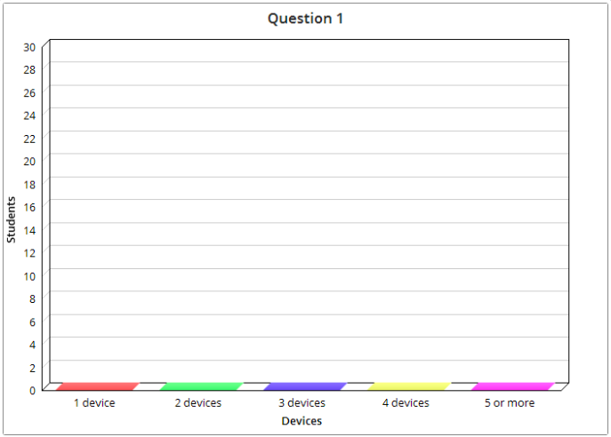

2. How many hours do you use your devices a day?
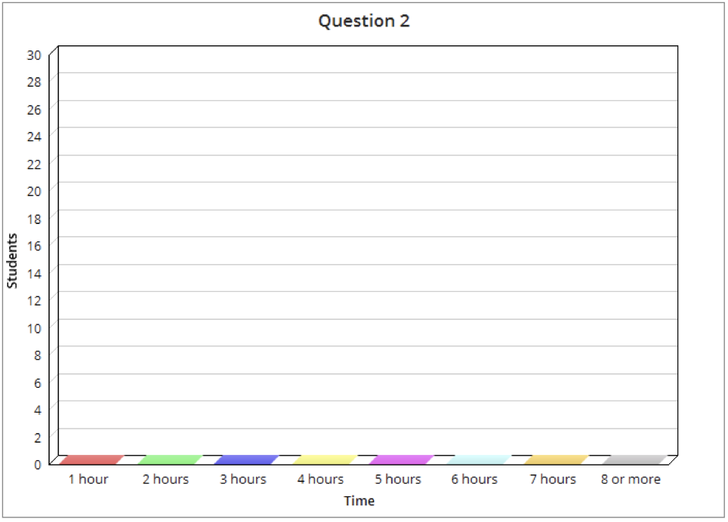

3. Do you use your devices for school work?
YES | NO
_________________ students | _________________ students

4. Do you use your devices for leisure?
YES | NO
_________________ students | _________________ students

5. Do you use your devices for communication?
YES | NO
_________________ students | _________________ students

6. Do you use devices to be informed?
YES | NO
_________________ students | _________________ students



