



Option D: Roll the dice.



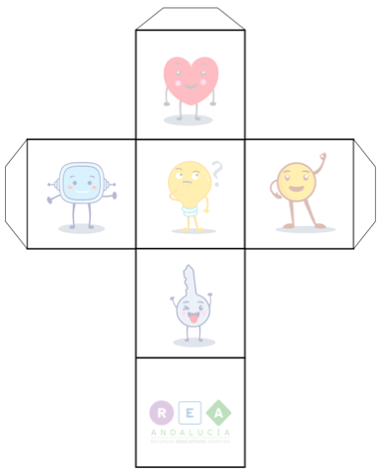
CAN
CAN’T
SHOULD
SHOULDN’T
CAN
SHOULD
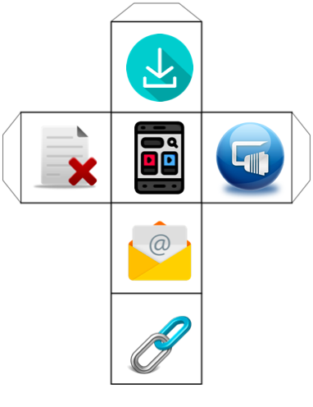

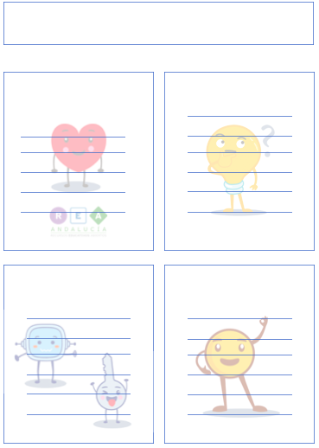
Write down your sentences.
CAN
CAN’T
SHOULD
SHOULD’T
He can send emails.



