



Option A. Answer the questions



NAME:

- What colour are these?
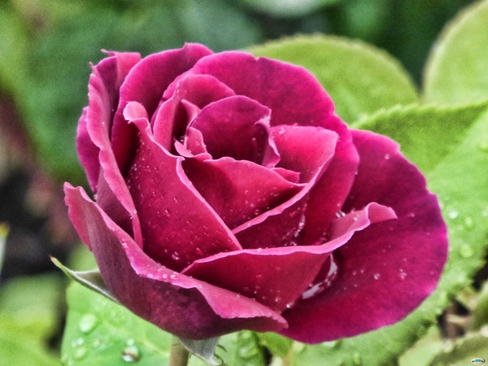
a) PINK
b) BLUE

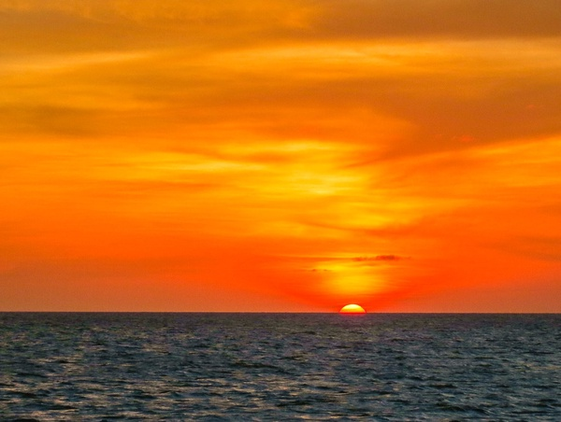
a) RED
                - b) ORANGE

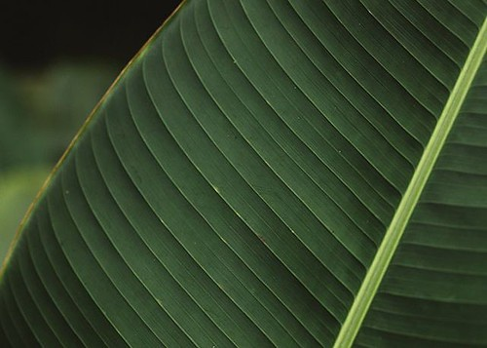
a) BLUE
b) GREEN

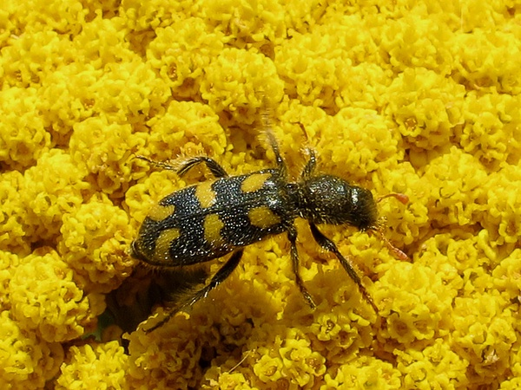
a) YELLOW
b) RED



