



Draw and write your TV show



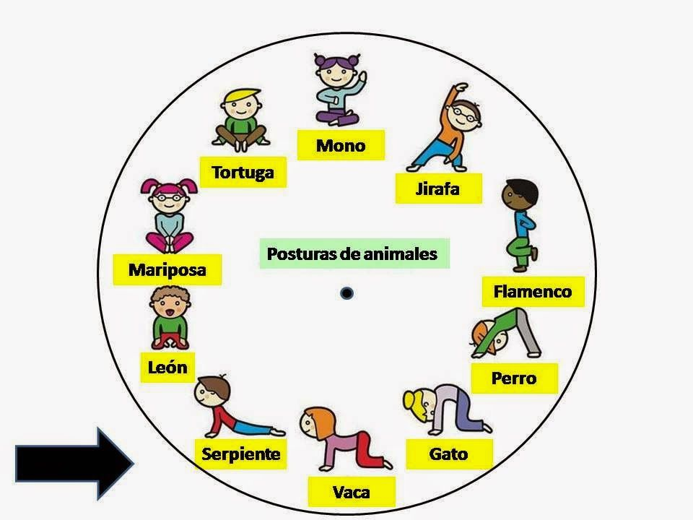

Draw your favourite yoga posture and your feeling.

I feel happy when I do the lion posture.

I feel ________________________________________________________________________



