Completa según vayas a realizar la tarea.
 | ¿Qué tarea debes realizar?  _____________________________________________________________________________________  _____________________________________________________________________________________  _____________________________________________________________________________________
 | ¿Cuál es el objetivo principal de la tarea?  _____________________________________________________________________________________  _____________________________________________________________________________________  _____________________________________________________________________________________  _____________________________________________________________________________________
  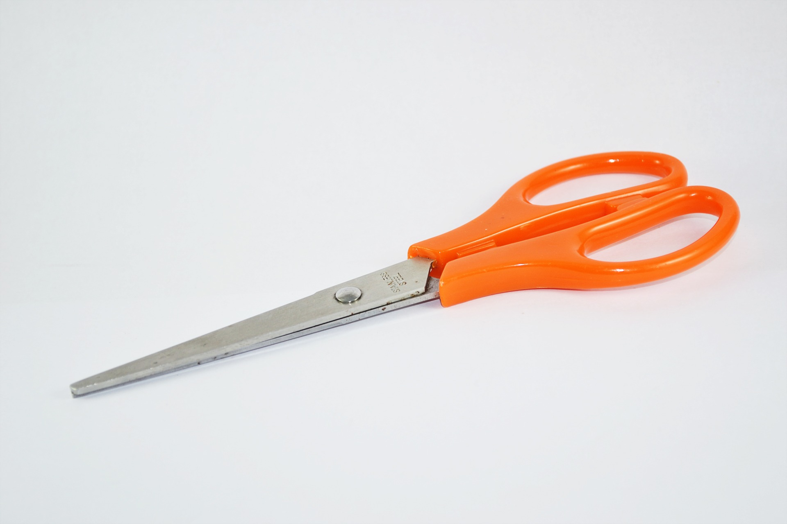 | ¿Cuáles son las partes necesarias para conseguir el objetivo? ¿Cuáles son las pequeñas tareas que tienes que hacer en cada parte?  - _________________________________________________________________________________________________________________________________________  - ______________________________________________________________________________________________________________________________  - ______________________________________________________________________________________________________________________________  - ______________________________________________________________________________________________________________________________  - _________________________________________________________________________________________________________________________________________  - ______________________________________________________________________________________________________________________________  - ______________________________________________________________________________________________________________________________  - ______________________________________________________________________________________________________________________________  - _________________________________________________________________________________________________________________________________________  - ______________________________________________________________________________________________________________________________  - ______________________________________________________________________________________________________________________________  - ______________________________________________________________________________________________________________________________  - _________________________________________________________________________________________________________________________________________  - ______________________________________________________________________________________________________________________________  - ______________________________________________________________________________________________________________________________  - ______________________________________________________________________________________________________________________________

HAZ TU LÍNEA DEL TIEMPO. | LUNES | MARTES | MIÉRCOLES | JUEVES | VIERNES
                                                            

