


Create your own domino



- YOUR DOMINO

Instructions:
- Write the name of the robots according to the pictures.
- Write what they are used for.
- Cut the cards.
- Play yourself with the cards. Match the robots with the same uses.
- You can also play with another classmate if he or she has done the same activity.
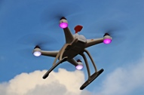

This robot is used for:
____________________
This robot is used for:
____________________
Type of robot
____________________
Type of robot
____________________


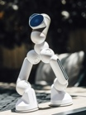
This robot _______ ___________________:
____________________
This robot _______ ___________________:
____________________
Type of robot
____________________
Type of robot
____________________


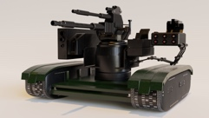
____________________ ___________________:
____________________
____________________ ___________________:
____________________
Type of robot
____________________
Type of robot
____________________

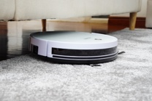
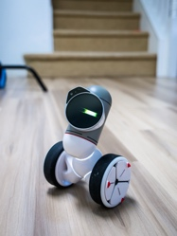
____________________ ___________________:
____________________

____________________ ___________________:
____________________

Type of robot
____________________
Type of robot
____________________



