


Think of your service robot



- How will your robot be?
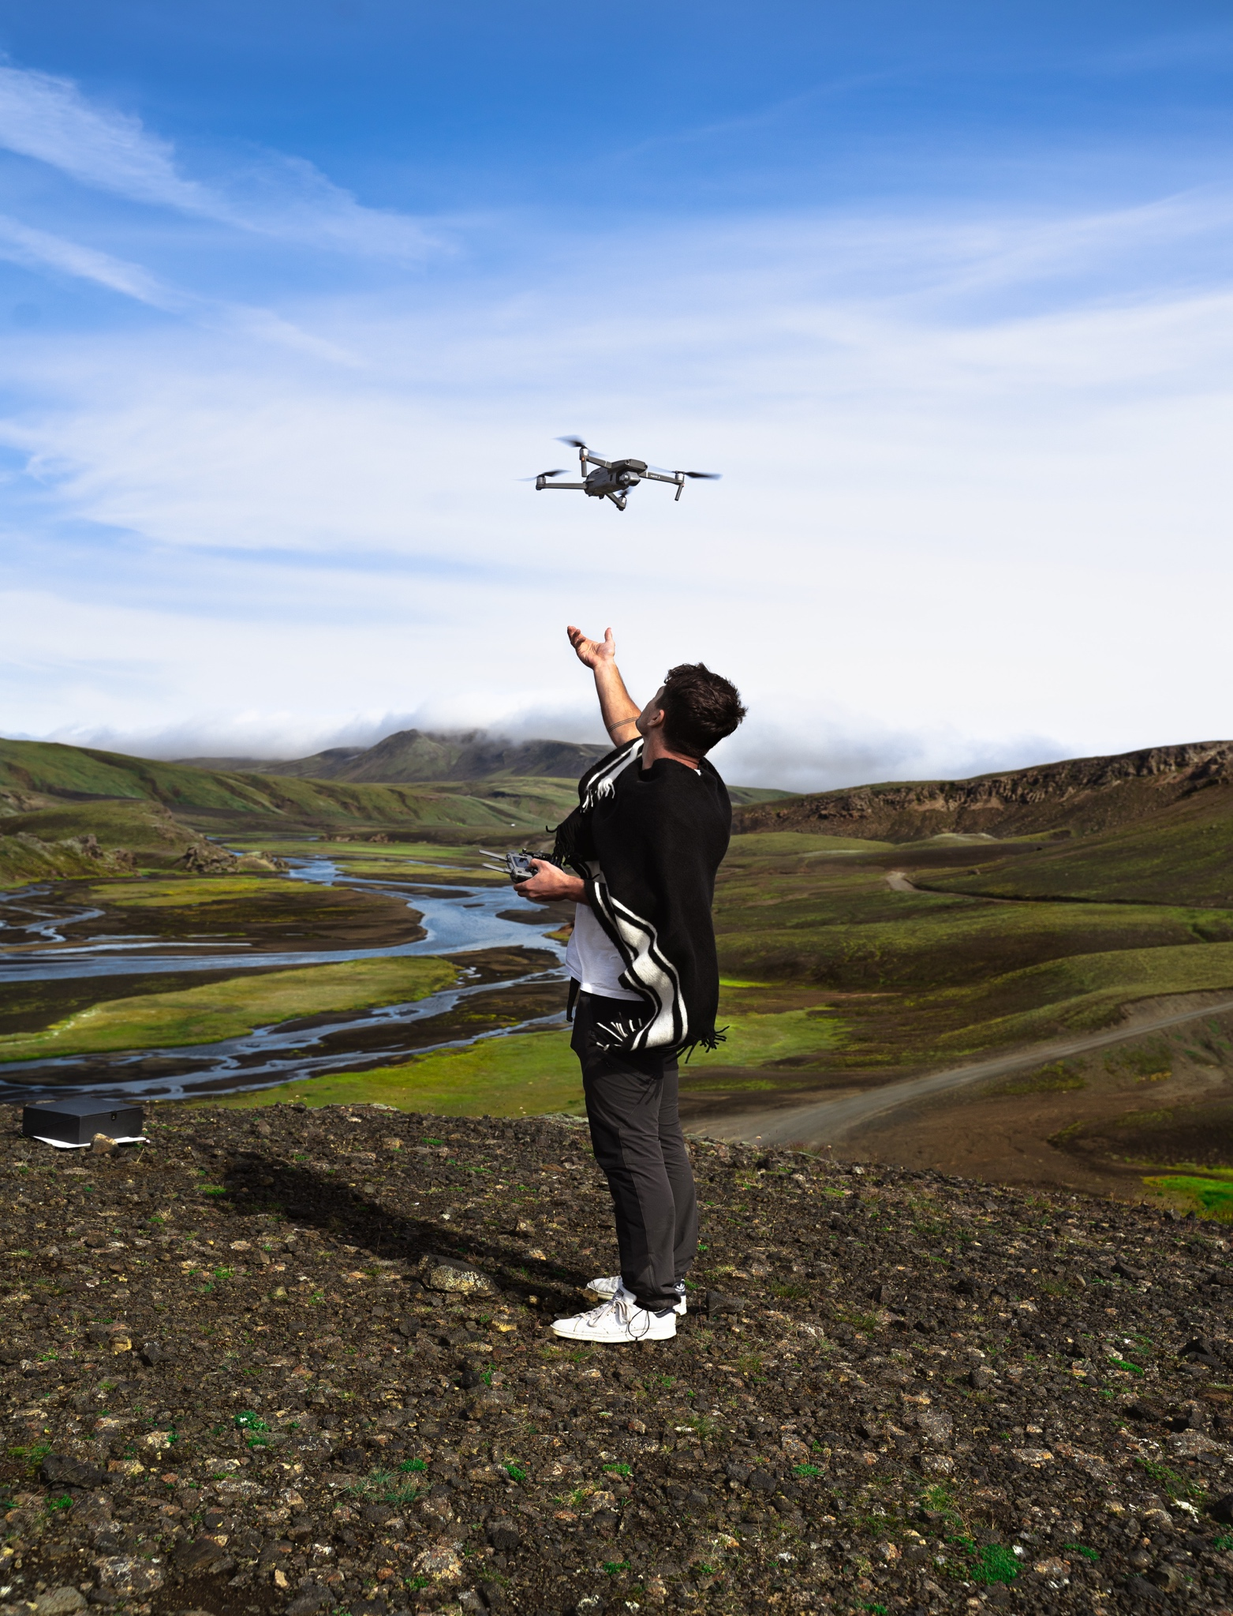
Name of the robot
__________________________________________
Shape and parts of the robot
Battery life
What it will be used for
Price
Persuading sentence
_________________________________________ _________________________________________
_________________________________________
_________________________________________

_________________________________________ _________________________________________
_________________________________________
_________________________________________

_________________________________________ _________________________________________
_________________________________________
_________________________________________

_________________________________________ _________________________________________
_________________________________________
_________________________________________

_________________________________________
Use a catchy name
It is … (shape)
It has … (parts)
It has a battery life of…
It will be used for (+ing)…
Try to convince that your robot is the best
It is… €



