

Stick characters: Part 1





First, have a look at the stick characters. Then, read the actions in the thought bubble. After that, think of sentences you can say and draw with those actions.





paint
wear
have got ride
drive
play live eat
drink read
listen

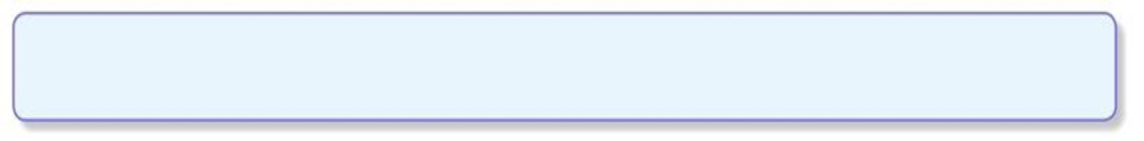
Stick characters: Pasrt 1


