



Create a graph and analyze it!



Option D: Create a graph from the tables with the gestation/incubation period of some viviparous and oviparous animals. Do you find any significant differences?
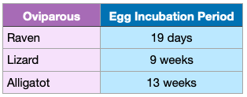
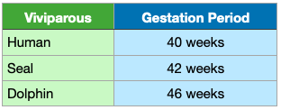

My Graph: ________________________________________

Conclusion



