



What you can't eat if you are...



Do you know there are people who can’t eat some food?
Can you help them to decide what is not good for them? Write food they can’t or don’t want to eat:

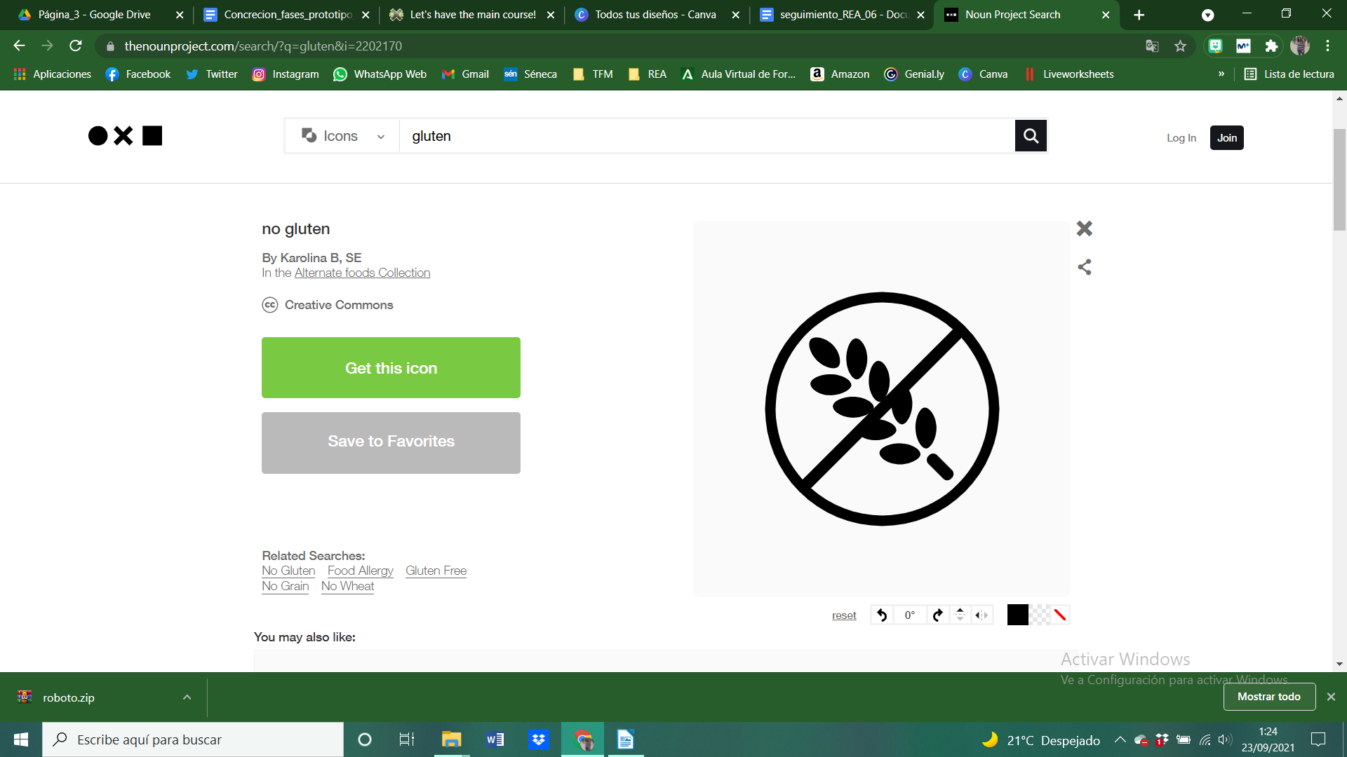  Gluten allergic | 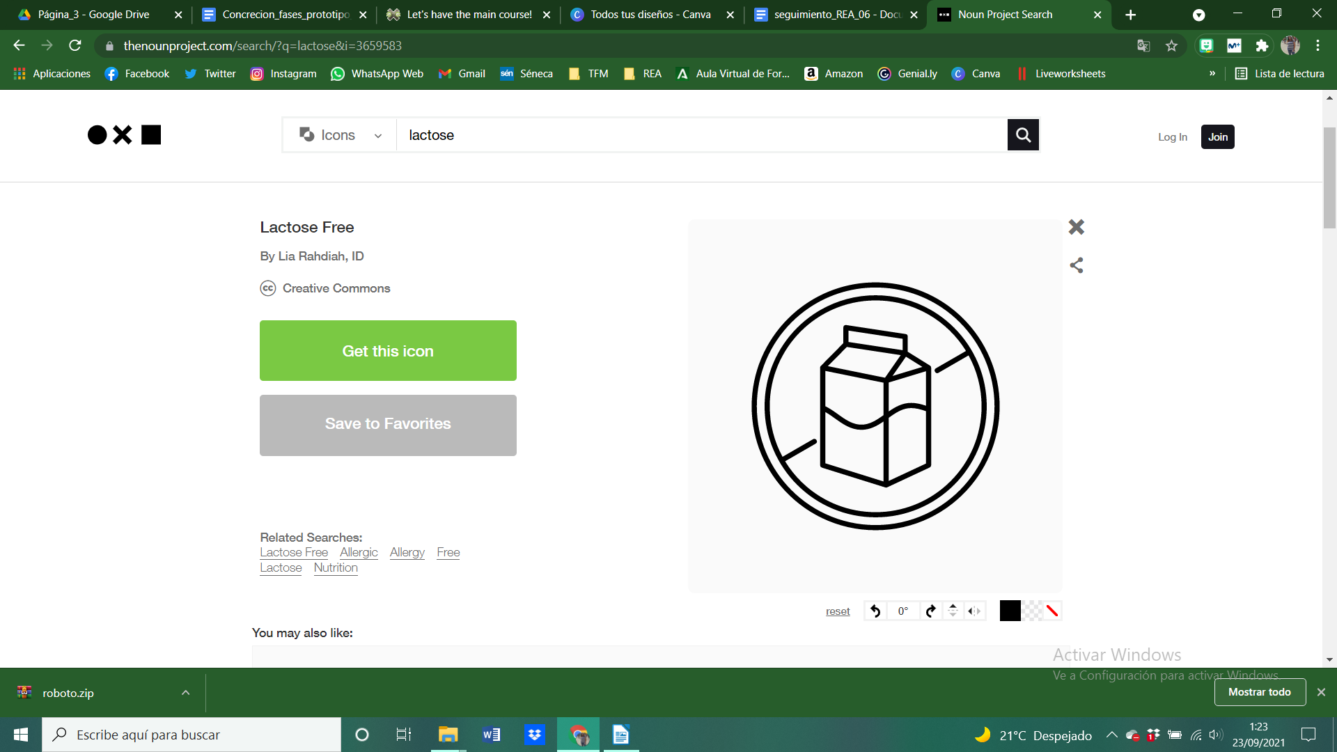  Lactose allergic | 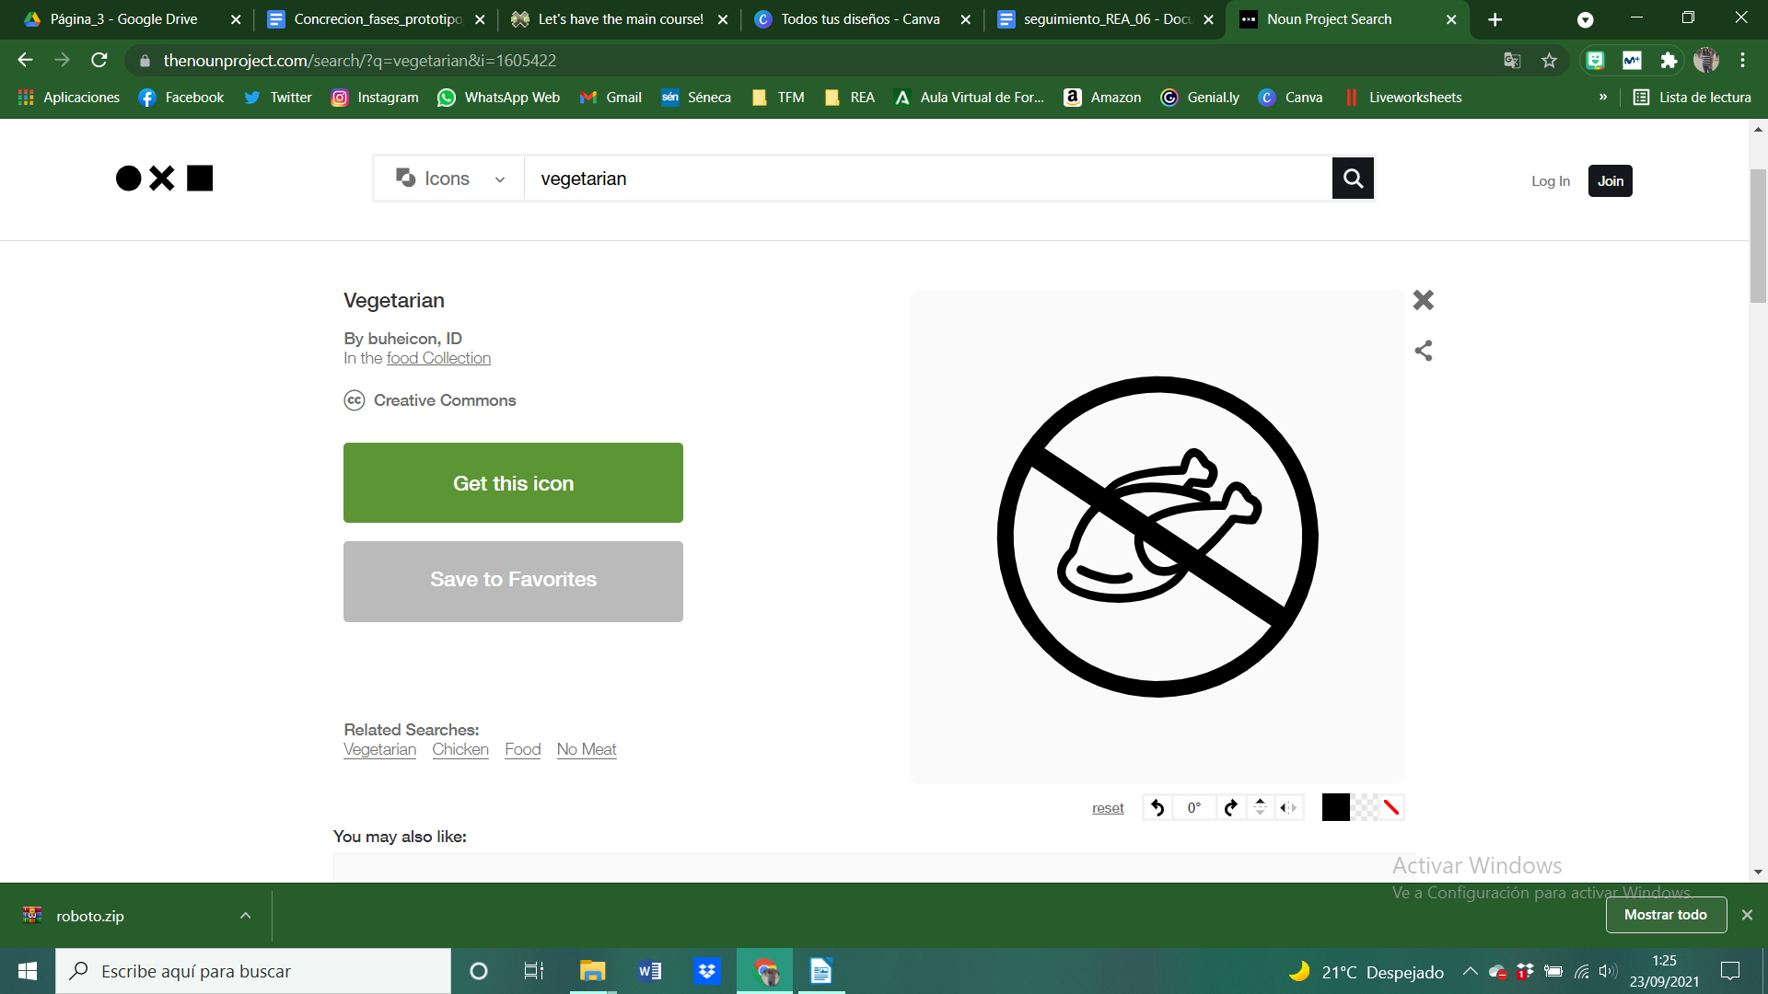  Vegetarian



