



Plan your model



Plan your model

-Colour water, sand and elements.
-Cut out the elements in the page below.
-Stick the elements on your map.
-Draw your path.

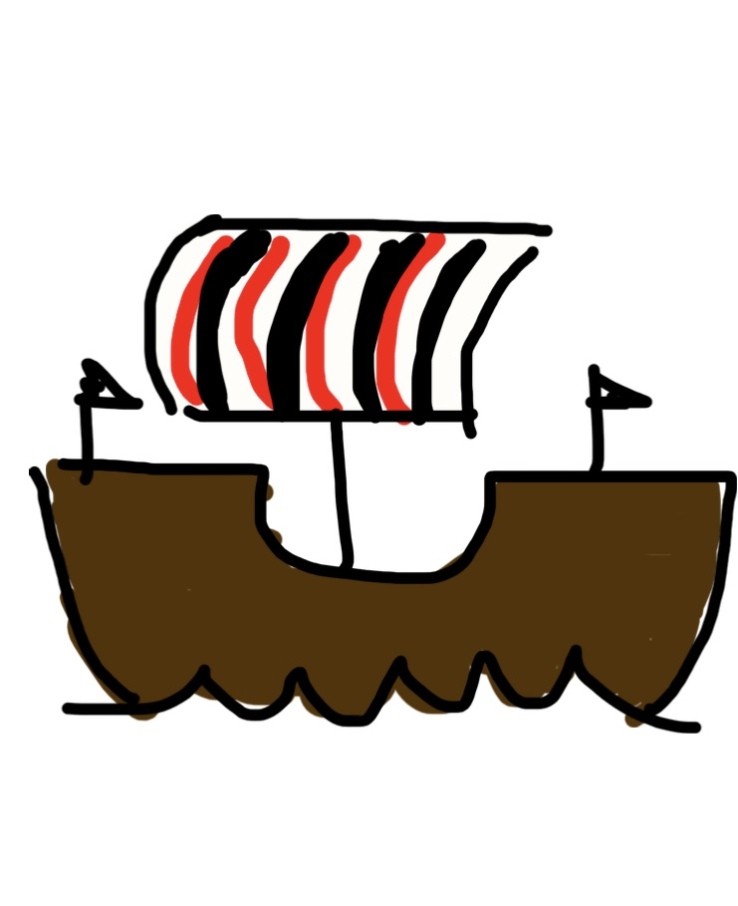
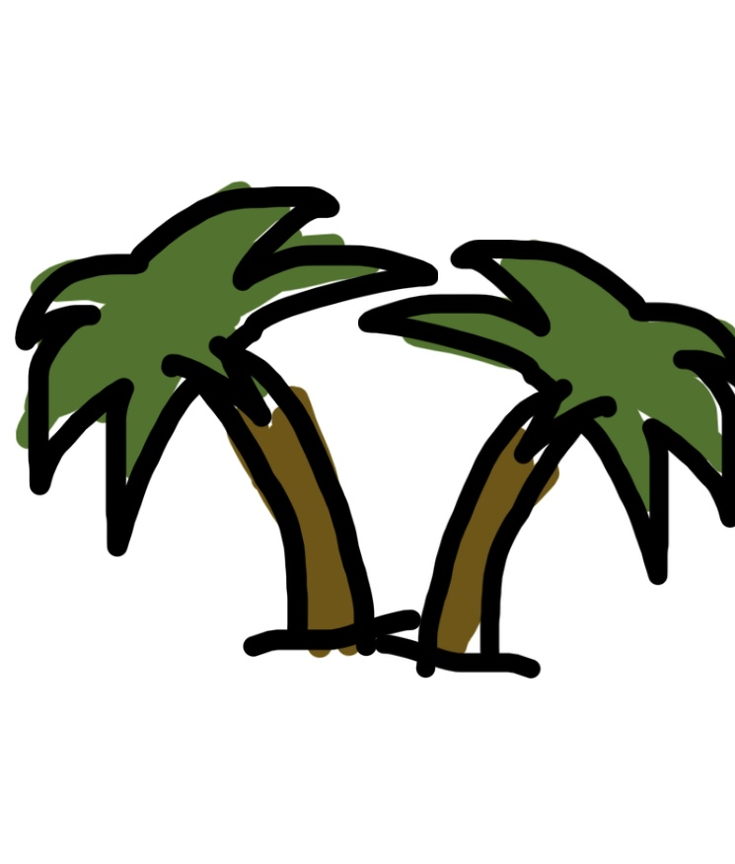

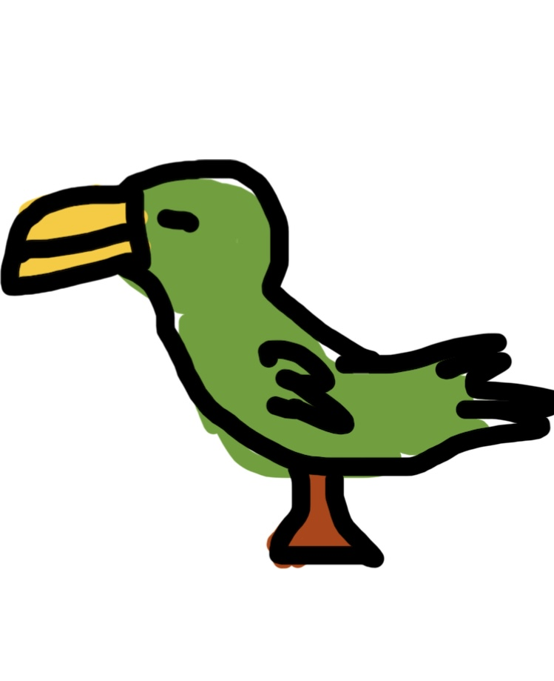
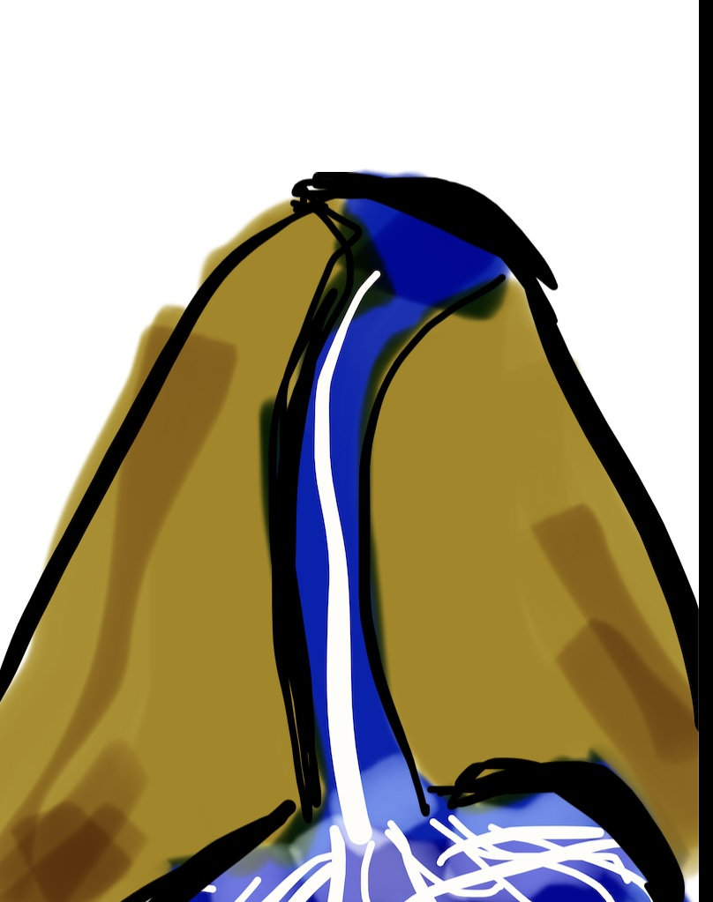
Draw your own elements:



