


Write an email



- Replay to the exchange student

Read the email from the exchange student. Then reply taking into account the information in the note. Circle in red the buttons where you will attach your brochure and click to send your email.
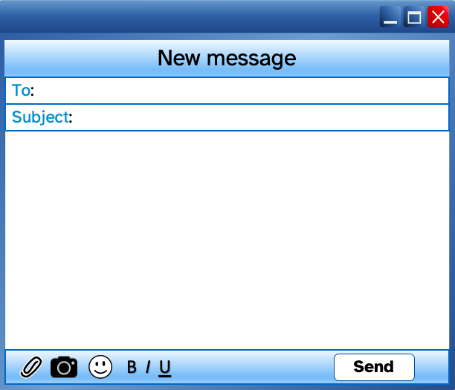

Hi! How are you?
I'm Sarah, the student who will go to your town.
I would like to know a bit about your town before I arrive. Could you send me some information?
We could make some cool plans. Have you thought of anything?
I'm looking forward to meeting you.
See you soon.
Charles
irene@ceipeducation.com
Looking forward to meeting you

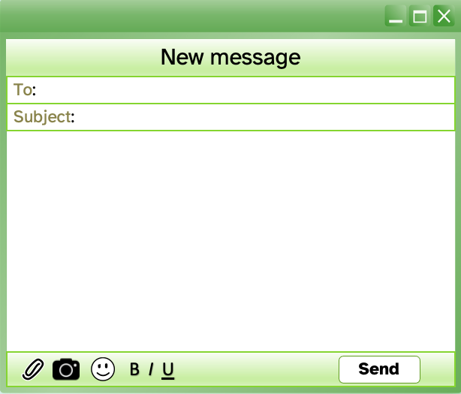



_______________________________

Write the email address.
Write the reason you are writing to.
Say hello.
Answer the questions:
- Attach a leaflet.
- Go to the aquarium.
- New species of fish, shark and whales.
Write a farewell and send your email.
_______________________________

___________________________________________________ ___________________________________________________
___________________________________________________
___________________________________________________
___________________________________________________ ___________________________________________________
___________________________________________________
___________________________________________________
___________________________________________________

It is important for our society to…
Monthly salary:



