


Write a postcard



- Invent your place of origin

Write the postcard answering Megan's questions. Don't forget to take the pictures into account.
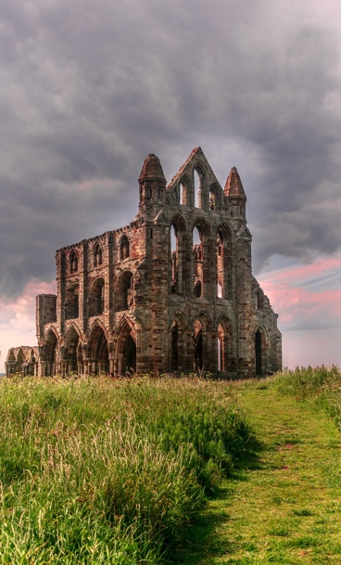


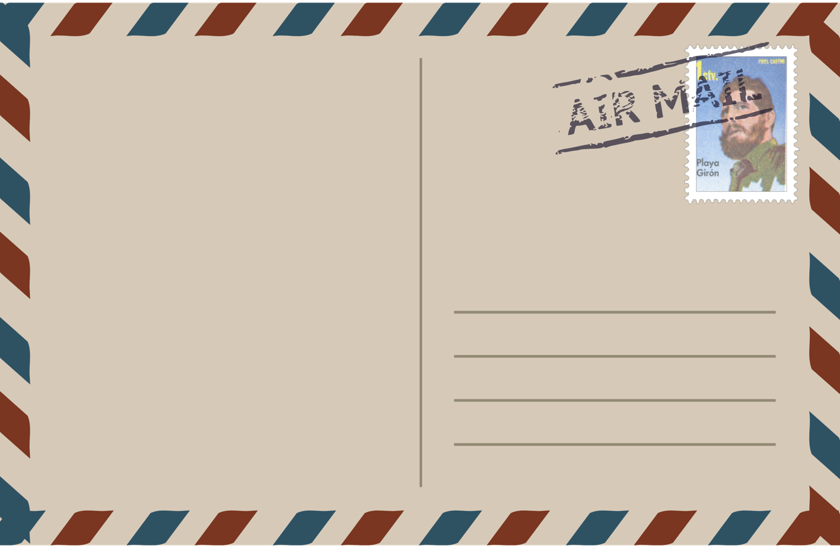
.



It is important for our society to…
Monthly salary:



