


See, think and wonder

WORK WITH YOUR CLASSMATES

I see: Write about what you have just seen in the pictures.
I think: Think about those pictures and write some ideas about them (Are they important for you? Are they important for culture? Should we take care of them?).
I wonder: Finally, do you have any questions? What would you ask? Write them.

I SEE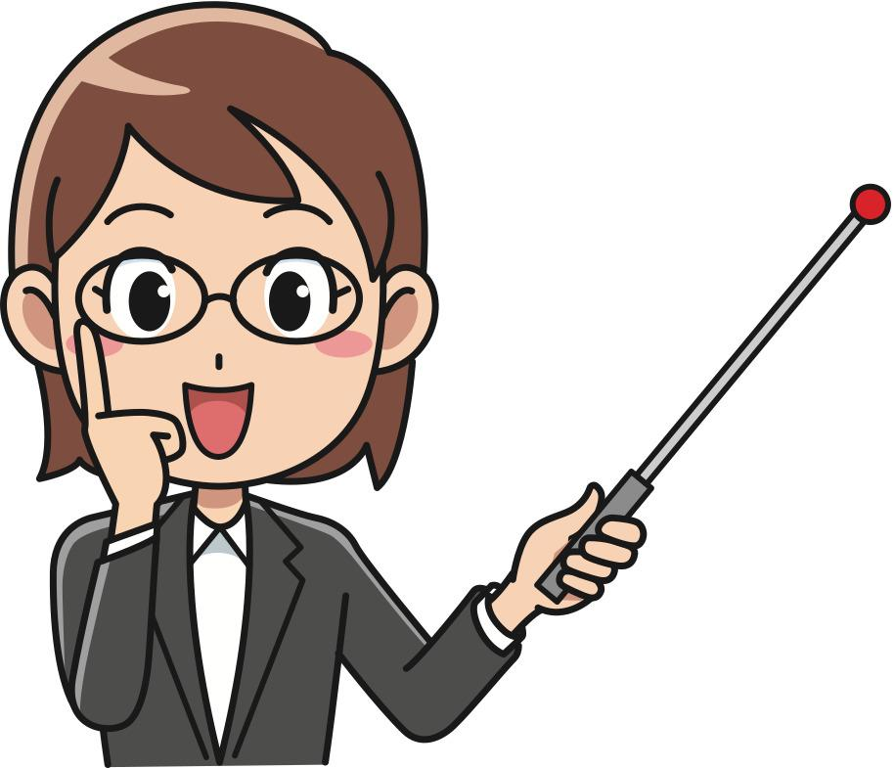 | I THINK   | I WONDER  



