


Draft template



- Complete your draft leaflet
- Write the name of the places, festivities or important people you want to talk about.
- Find information about them on the internet.
- Write briefly why this aspect is important to you.

  Other interesting cultural things: | 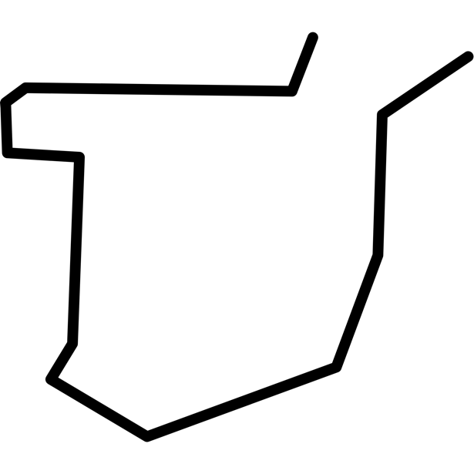    My Autonomous Community is… | 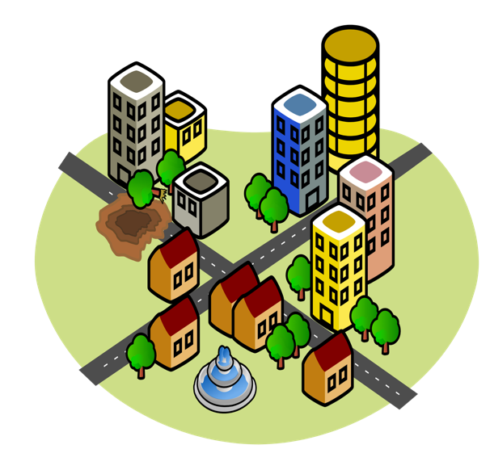  Write the name of your town/city

Image  NAME: ………………………………………………….  This is a (monument/festivity/place of interest/important person) ……….……. ……………………………………………………………….  It is important because it is………………. ……………………………………………………………….  ……………………………………………………………….  ……………………………………………………………….  ……………………………………………………………….  ………………………………………………………………. | Image  ………………………………………………………………. ……………………………………………………………….  ……………………………………………………………….  ……………………………………………………………….  ……………………………………………………………….  ……………………………………………………………….  ……………………………………………………………….  NAME: …………………………………………………. | Image  NAME: ………………………………………………….  ………………………………………………………………. ……………………………………………………………….  ……………………………………………………………….  ……………………………………………………………….  ……………………………………………………………….  ……………………………………………………………….  ……………………………………………………………….
Monthly salary:



