


Culture: glossary of terms


- Glossary
THE PLACE WHERE I LIVE

MONUMENTS
PLACES OF INTEREST
FESTIVITIES

CASTLE
TOWER
SHOPPING CENTRE
BEACH
SAINT JEAN DAY
AL SOULS’ DAY
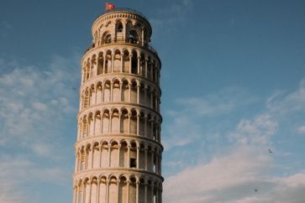
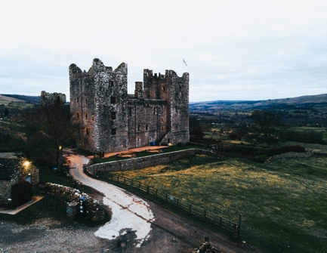
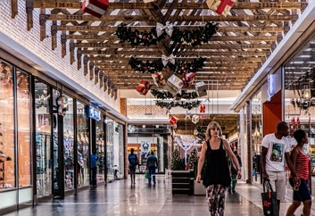
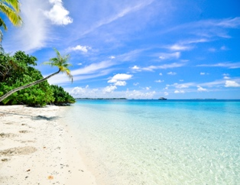
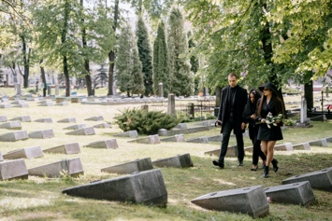
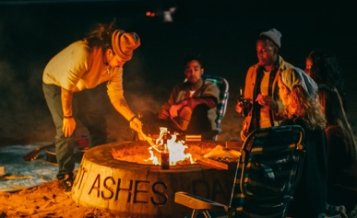

CATHEDRAL
AQUARIUM
LOCAL FESTIVAL
HOLY WEEK
NATURAL PARK





