


Cultural game


Index

TITLE |  | PÁGE
- Look at these dices about cultural elements | ……………………………………. | 3
- Let’s play | ……………………………………. | 5

- Look at these dice about cultural elements
Cut and paste the dice. Then write the following sentences:

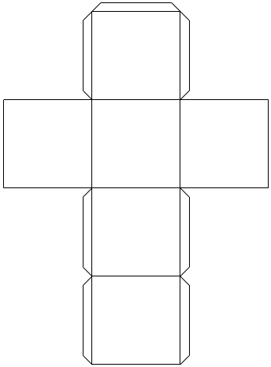
Die 1:
- How about...? (write it on three sides)
- I think... (write it on three sides)

Die 2:
- Castle
- Cathedral
- Beach
- Natural park
- Holy week
- All Souls’ Day

- Let’s play

It is time to play!
First, throw the die 1.
Second, throw the die 2.
Then make sentences with the words you can see at the top of the dice.
Write the sentences in the chart below.

DIE 1 | DIE 2 | SENTENCES



