

Fortune wheel. Part 1





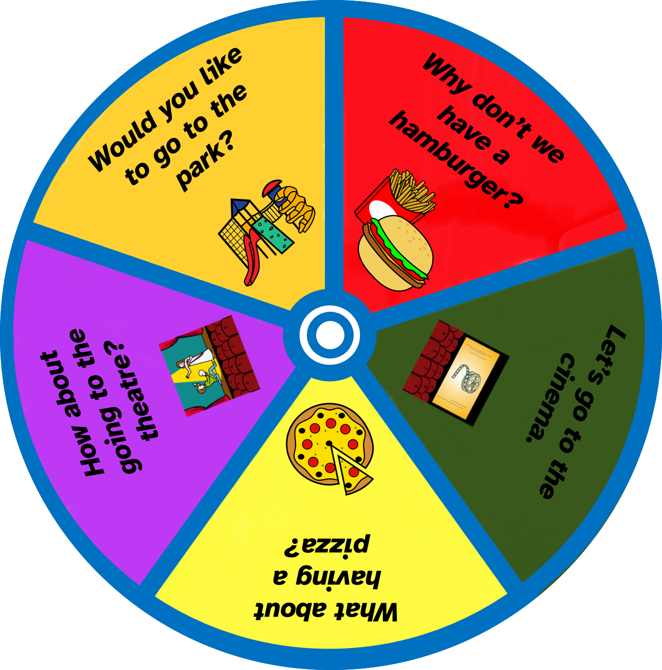

Firstly, cut out the two pieces. Secondly, cut out the part with the dashed lines. Thirdly, put the wheel on the right on top of the other using a bookbinder. Finally, turn the wheel and suggest what you get.

Fortune wheel. Part 1


