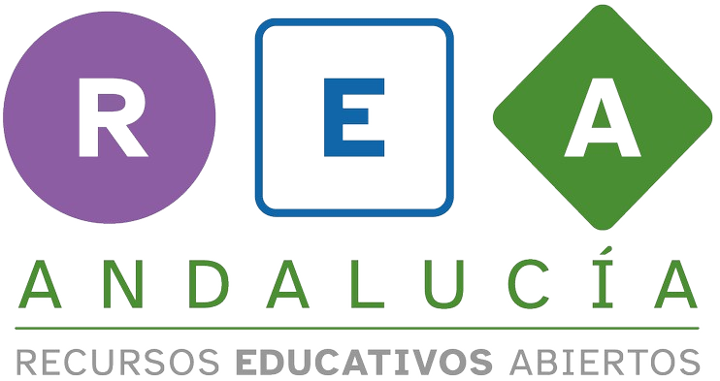

Peer assessment




Peer assessment rubric.
Instrucciones para la rúbrica: Tick each aspect on the left from one to four according to what you think about your partner.

PEER ASSESSMENT
Dimension/Levels of Achievement | 1 Keep trying! | 2 Not bad! | 3 Well done! | 4 Excellent
To express what products are made of | He/She can express what a few products are made of. | He/She can express what some products are made of. | He/She can express what most products are made of. | He/She can express what all products are made of.
To give products a new life | He/She has difficulties reusing products. | He/She can reuse products with some help. | He/She can reuse products on their own by following instructions. | He/She can reuse products on their own by following instructions. Also, he/she can help others reuse products.
To catalogue reused objects | He/She can cataloque an object including one or two of these aspects: title, condition, category or description.  The description does not include both the original and the final product. | He/She can catalogue an object including three aspects: title, condition, category or description.  The description does not include both the original and the final product. | He/She can catalogue an object including all the aspects: title, condition, category and description.  The description does not include both the original and the final product. | He/She can catalogue an object including all the aspects: title, condition, category and description.  The description includes both the original and the final product.

Peer assessment

Peer assessment rubric.
Instrucciones para la rúbrica: Tick each aspect on the left from one to four according to what you think about your partner.

PEER ASSESSMENT
To design a poster for an exhibition | He/She can design a poster including one or two of the following elements: headline, easy-to-read texts, free images or colours.  The poster does not fulfill the purpose. | He/She can design a poster including three of these elements: headline, easy-to-read texts, free images or colours.  The poster does not fulfill the purpose. | He/She can design a poster including all the elements: headline, easy-to-read texts, free images and colours.  The poster does not fulfill the purpose. | He/She can design a poster including all the elements: headline, easy-to-read texts, free images and colours.  The poster fulfills the purpose.
To record a video slogan | He/She has difficulties recording a video slogan. | He/She can record a video slogan with some help. | He/She can record a video slogan on their own by following instructions. | He/She can record a video slogan on their own by following instructions. Also, he/she can help others to record their videos.

Peer assessment



