

Peer assessment





First, choose a colour for the labels below. Then, colour the shopping trolleys according to what you think about your classmates’ second-hand shop.
How did you like your classsmates’ second-hand shop?





Colour the almost empty shopping trolley if you don’t like it too much (So-so – 30%).

Colour the half empty shopping trolley half empty if you like it a bit (Good – 50%).

Colour the half full shopping trolley if you like it (Very good – 70%).

Colour the full shopping trolley if you like it a lot (Excellent! (100%).

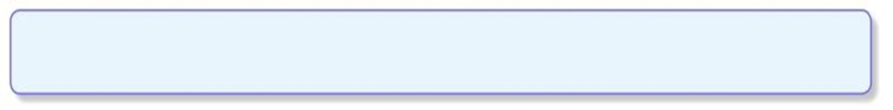
Peer assessment


